**Description**:

A donut chart is similar to a pie chart in that it shows the relationship of parts to a whole. The only difference is that the center is blank and allows space for a label or icon.

A donut chart represent data as slices, where the size of each slice is determined by the slice value relative to the sum of the values of all slices. Each data series that you plot in a donut chart adds a ring to the chart. These rings have distinct colors for easy representation of the data slices in donut chart.

In the custom donut chart, we can add metrics on the center of the chart. Also, we have the ability to add secondary measures and threshold limits for each measure. Find the sample screenshot below:

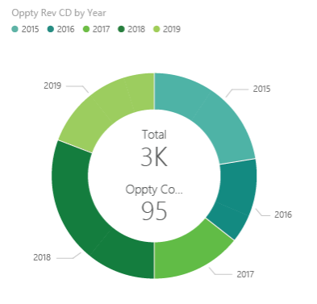

* The sum of the donut chart values must add up to 100%.
* Too many categories make it difficult to read and interpret.
* Donut charts are best used to compare a particular section to the whole, rather than comparing individual sections with each other.